AWS Security Group Configuration
05/11/2026
1.Inbound Port Rules
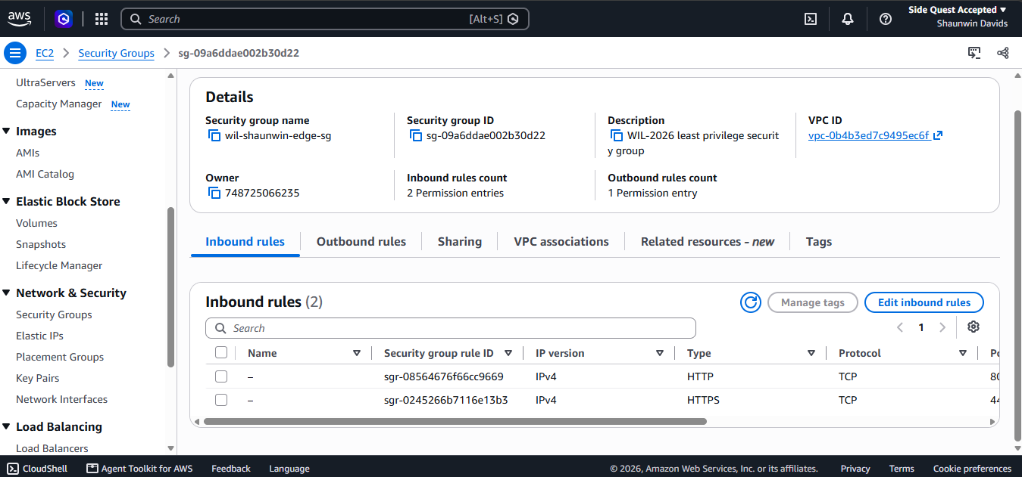

SecurityGroup | EC2 | Side Quest Accepted

2. Written justification:
Project: WIL-2026
Security Groups: wil-shaunwin-edge-sg
Inbound rule justification
1.HTTPS- Port 443
HTTPS allows customer to access the website using an encrypted connection. The source is set to 0.0.0.0/0 because the website is intended to be publicly accessible.
2.HTTP- Port 80
HTTP allows visitors to reach the website when an HTTP connection is needed, for example, to redirect them to the secure HTTPS version. This rule is only required if the application uses HTTP for this purpose.

